**Chapter 4**

**Tables / Collections/ Use Case Diagram**

**4.1LIST OF TABLES**

**4.1.1 Register Table**

|  |  |  |
| --- | --- | --- |
| **Field** | **Description** | **Extra** |
| time | timestamp | current_timestamp()  (default) |
| id | int(11) |  |
| first name | varchar(255) |  |
| last name | varchar(255) |  |
| email | varchar(255) |  |
| password | Date |  |
| birthday | varchar(255) |  |
| gender | varchar(255) |  |
| user_image | varchar(255) | user_black_profile.jpg(default image) |
| cover_image | varchar(255) |  |

**4.1.2 User Details Table**

|  |  |
| --- | --- |
| **Field** | **Description** |
| id | int(11) |
| user_id | int(11) |
| status | varchar(20) |
| profession | varchar(20) |
| education | varchar(20) |
| college | varchar(255) |

**4.1.3 User Post Table**

|  |  |
| --- | --- |
| **Field** | **Description** |
| post_id | int(255) |
| user_id | int(255) |
| post_content | text |
| upload_image | varchar(255) |

**4.1.4 Message Table**

|  |  |
| --- | --- |
| **Field** | **Description** |
| message_id | int(11) |
| User_id | int(11) |
| message | text |
| time | timestamp |

**4.2 Use Case Diagram**

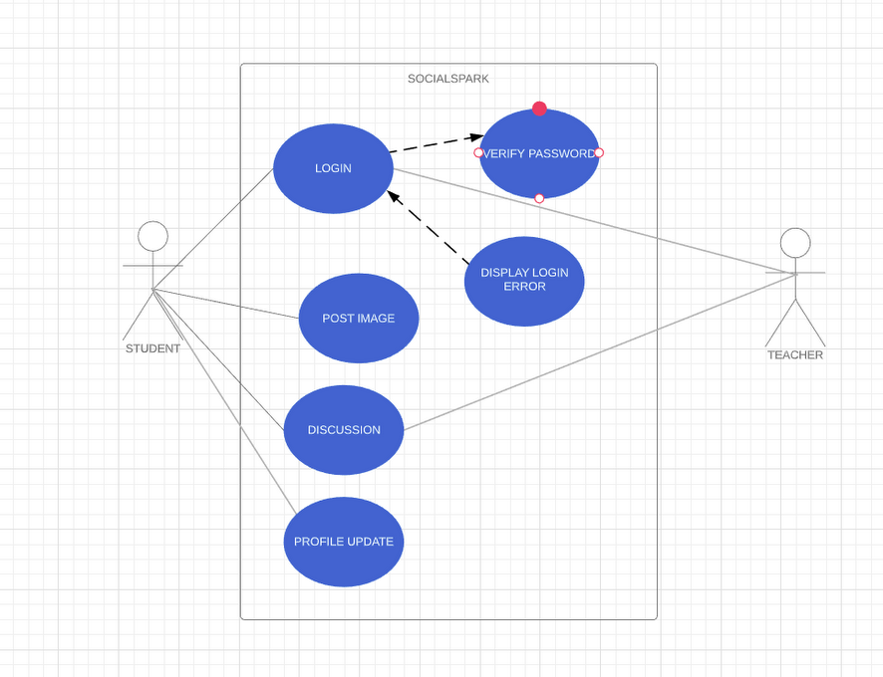

**4.2 Use Case Diagram**